Supporting information

Fig. S1 The nucleotide sequence and amino acid sequence of wheat DREB gene. (a), (b) and (c) represented the sequence of DREB2, DREB6 and Wdreb2, respectively. The box and underline respectively represented nuclear localization signal and AP2/EREBP domain.
Fig. S2 Multiple alignment of wheat DREB in and its homologous sequences. (a), (b) and (c) was the alignment between homologous sequences with DREB2, DREB6 or Wdreb2, respectively.
Fig. S3 The distribution of CpG island in the promoter of wheat DREB gene. (a), (b) and (c) represented the prediction result of CpG island in the promoter of DREB2, DREB6 or Wdreb2, respectively, CpG island was shown by the shaded part.
Fig. S4 Bisulfite sequencing result for the promoter of wheat DREB gene. Red, blue and green circles represented CG, CHG or CHH, filled and hollow circles denoted methylated and unmethylated cytosine, respectively.
Table S1 The cis-acting elements in the promoter of DREB2
Table S2 The cis-acting elements in the promoter of DREB6
Table S3 The cis-acting elements in the promoter of Wdreb2
Table S4 Correlation between promoter methylation and expression of DREB gene
Table S5 Primers used in this study

(a) 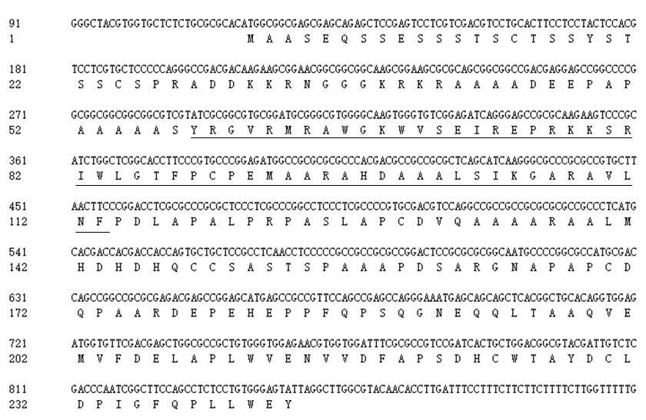

(b) 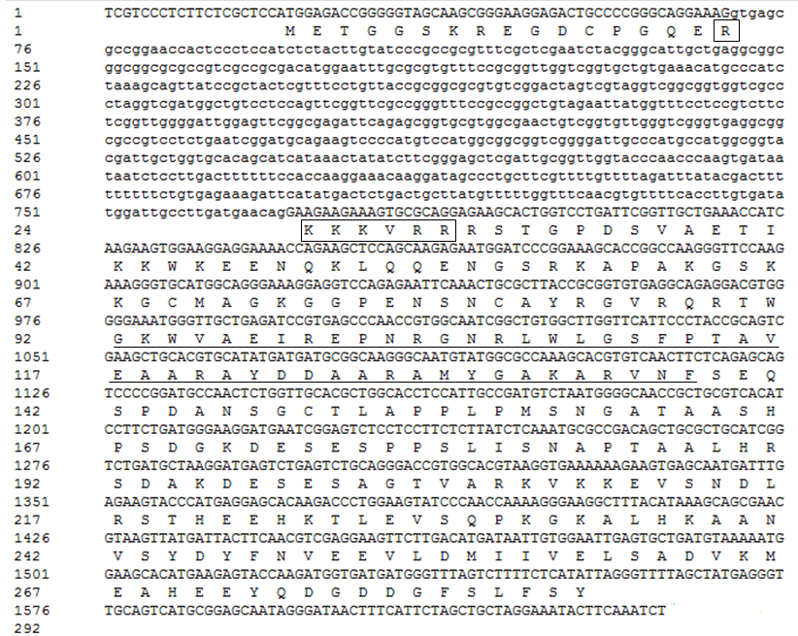

(c) 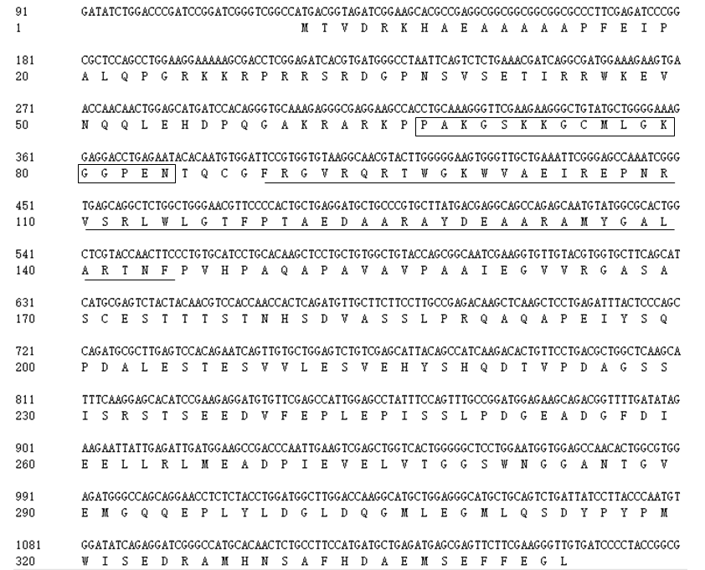
Fig. S1 The nucleotide sequence and amino acid sequence of wheat DREB gene. (a), (b) and (c) represented the sequence of DREB2, DREB6 and Wdreb2, respectively. The box and underline respectively represented nuclear localization signal and AP2/EREBP domain.

(a) 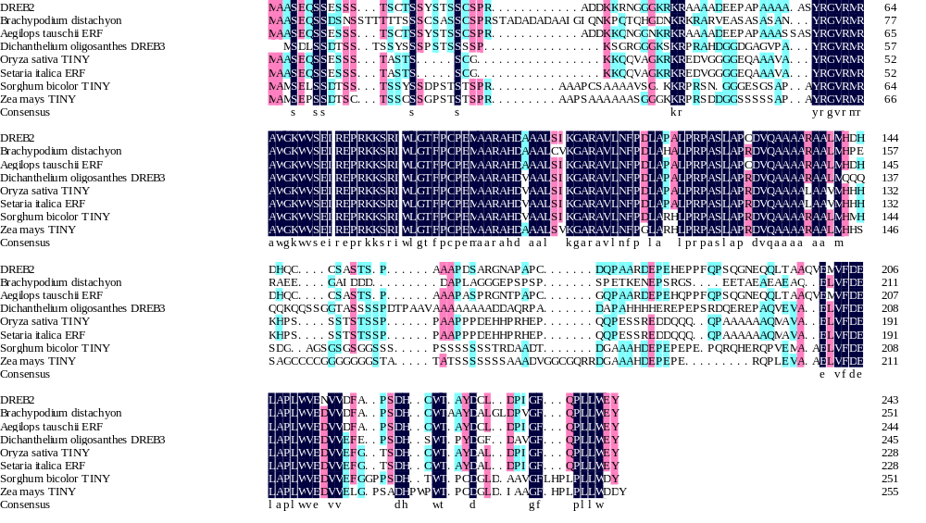
(b) 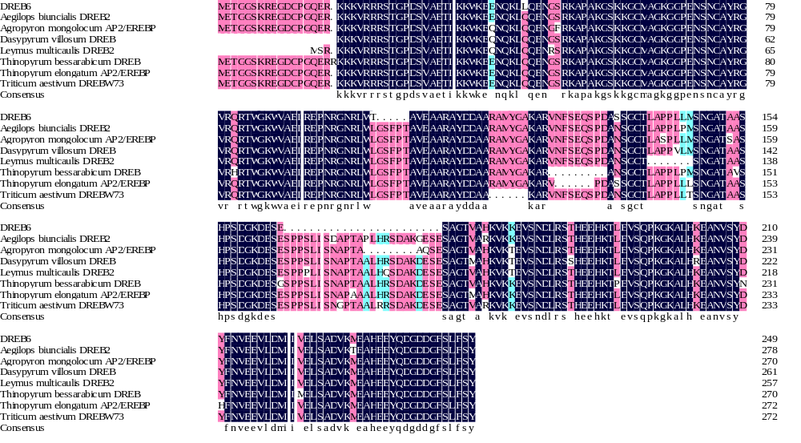
(c)
Fig. S2 Multiple alignment of wheat DREB in and its homologous sequences. (a), (b) and (c) was the alignment between homologous sequences with DREB2, DREB6 or Wdreb2, respectively.

(a) 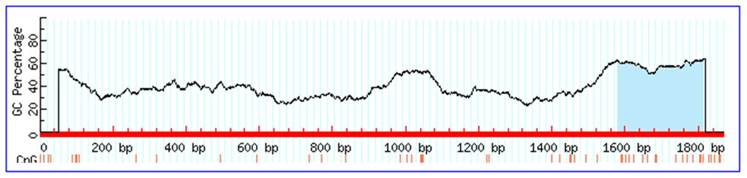
(b) 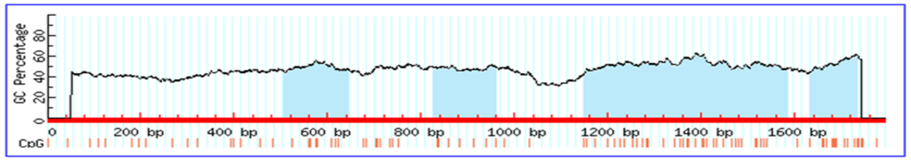
(c) 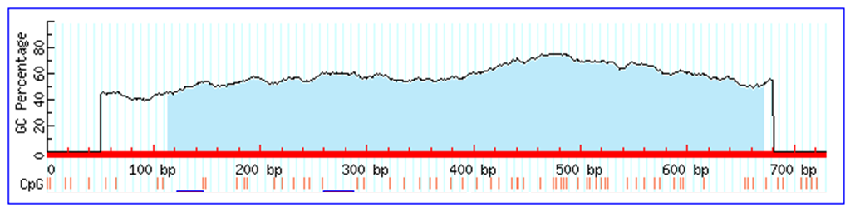
Fig. S3 The distribution of CpG island in the promoter of wheat DREB gene. (a), (b) and (c) represented the prediction result of CpG island in the promoter of DREB2, DREB6 or Wdreb2, respectively, CpG island was shown by the shaded part.

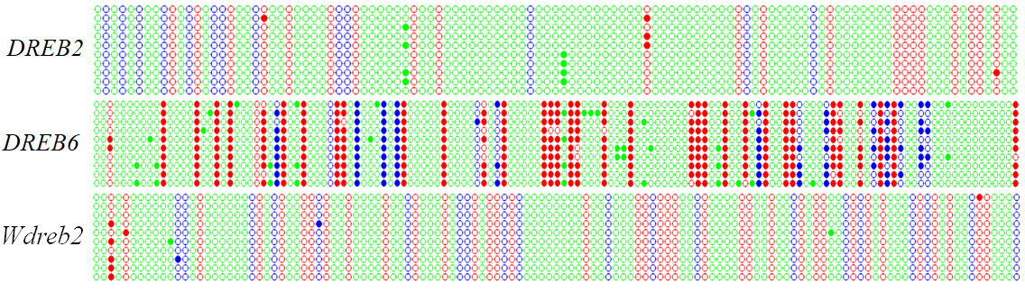
Fig. S4 Bisulfite sequencing result for the promoter of wheat DREB. Red, blue and green circles represented CG, CHG or CHH, filled and hollow circles denoted methylated and unmethylated cytosine, respectively. Each row represented the sequencing result of one positive clone.

Table S1 The cis-acting elements in the promoter of DREB2
Name | Sequence | Function | Number
TATA-Box  CAAT-box  ABRE  ACE  ARE  MBS  LTR  C-repeat/DRE  EIER  TGACG-motif  Skn-1_motif  SP1  GAG-motif  GARE-motif  TCT-motif  TCA-element  TGA-element  OCT  Circadian  MNF  HD-Zip  HD-Zip  GT1-motif  GC-motif  GATA-motif  Box-4 | TATAWAW  CAAT  CGTACGTGCA  AAAACGTTTA  TGGTTT  CAACTG  CCGAAA  TGGCCGAC  TTCGACC  TGACG  GTCAT  CC(G/A)CCC  AGAGATG  TCTGTTG  TCTTAC  TCAGAAGAGG  AACGAC  CGCGGATC  CAANNNNATC  GTGCCC(A/T)  CAAT(A/T)ATTG  CAAT(G/C)ATTG  GGTTAAT  CCCCCG  GATAGGA  ATTAAT | Core promoter element around -30 of transcription start  Common cis-acting element in promoter and enhancer regions  Cis-acting element involved in the abscisic acid responsiveness  Cis-acting element involved in light responsiveness  Cis-acting regulatory element essential for the anaerobic induction  MYB binding site involved in drought-inducibility  Cis-acting element involved in low-temperature responsiveness  Regulatory element involved in cold-and dehydration-responsiveness  Elicitor-responsive element  Cis-acting regulatory element involved in the MeJA-responsiveness  Cis-acting regulatory element required for endosperm expression  Light responsive element  Part of a light responsive element  Gibberellin-responsive element  Part of a light responsive element  Cis-acting element involved in salicylic acid responsiveness  Auxin-responsive element  Cis-acting regulatory element related to meristem specific activation  Cis-acting regulatory element involved in circadian control  Light responsive element  Element involved in differentiation of the palisade mesophyll cells  Element involved in the control of leaf morphology development  Light responsive element  Enhancer-like element involved in anoxic specific inducibility  Part of a light responsive element  Part of a conserved DNA module involved in light responsiveness | 26  34  5  1  3  2  1  1  1  1  1  4  2  1  1  2  1  1  1  1  1  1  2  2  1  1

Table S2 The cis-acting elements in the promoter of DREB6
Name | Sequence | Function | Number
AuxRR-core  TATA-Box  CAAT-box  ABRE  ACE  ARE  MBS  LTR  CATT-motif  CGTCA-motif  GAG-motif  GARE-motif  P-box  Circadian  DRECRT  ERE  SP1  Box I  GC-motif  Box-W1 | GGTCCAT  TATAWAW  CAAT  CGTACGTGCA  AAAACGTTTA  TGGTTT1  CAACTG  CCGAAA  GCATTC  CGTCA  GGAGATG  AAACAGA  CCTTTTG  CAANNNNATC  RCCGAC  ATTTCAAA  GGGCGG  TTTCAAA  CCCCCG  TTGACC | Cis-acting regulatory element involved in auxin responsiveness  Core promoter element around -30 of transcription start  Common cis-acting element in promoter and enhancer regions  Cis-acting element involved in the abscisic acid responsiveness  Cis-acting element involved in light responsiveness  Cis-acting regulatory element essential for the anaerobic induction  MYB binding site involved in drought-inducibility  Cis-acting element involved in low-temperature responsiveness  Part of a light responsive element  Cis-acting regulatory element involved in the MeJA-responsiveness  Part of a light responsive element  Gibberellin-responsive element  Gibberellin-responsive element  Cis-acting regulatory element involved in circadian control  Drought, highsalt and cold-responsive element  Ethylene-responsive element  Light responsive element  Light responsive element  Enhancer-like element involved in anoxic specific inducibility  Fungal elicitor responsive element | 1  18  24  10  2  1  5  1  1  3  1  2  1  1  1  1  6  1  1  1

Table S3 The cis-acting elements in the promoter of Wdreb2
Name | Sequence | Function | Number
5UTRpy-rich stretch  TATA-Box  CAAT-box  CAT-box1  ABRE  ACE  O2-site  C-repeat/DRE  C-box  CE3  MRE  LTR  GAG-motif  GARE-motif  SP1  as1  CGTCA-motif | TTTCTTCTCT  TATAWAW  CAAT  GCCACT  CGTACGTGCA  AAAACGTTTA  GATGACATGG  TGGCCGAC  CTGACGTCAG  GACGCGTGTC  AACCTAA  CCGAAA  AGAGATG  TCTGTTG  CCGCCC  TGACGTCA  CGTCA | Cis-acting element conferring high transcription levels  Core promoter element around -30 of transcription start  Common cis-acting element in promoter and enhancer regions  Cis-acting regulatory element related to meristem expression  Cis-acting element involved in the abscisic acid responsiveness  Cis-acting element involved in light responsiveness  Cis-acting regulatory element involved in zein metabolismregulation  Regulatory element involved in cold and dehydration responsiveness  Cis-acting regulatory element involved in light responsiveness  Cis-acting element involved in ABA and VP1 responsiveness  MYB binding site involved in light responsiveness  Cis-acting element involved in low-temperature responsiveness  Part of a light responsive element  Gibberellin-responsive element  Light responsie element  Cis-acting regulatory element involved in the root specificexpression  Cis-acting regulatory element involved in the MeJA-responsiveness | 1  5  4  1  5  1  1  1  1  1  1  1  1  1  2  1  2

Table S4 Correlation between promoter methylation and expression of DREB gene
Gene  Site | Pearson’s r
Gene  Site | DREB2 | DREB6 | Wdreb2
CG | -0.981 | -0.952 | -0.986
CHG | -0.950 | -0.327 | -0.973
CHH | 0.656 | -0.509 | -0.878

Table S5 Primers used in this study
Purpose | Primer | Sequence（5’ to 3’） | Target fragment (bp)
Gene cloning | DREB2-F | CTACTCCCTGCACGGTCCT  GCCAAGCCTAATACTCCCAC | 829
Gene cloning | DREB2-R | CTACTCCCTGCACGGTCCT  GCCAAGCCTAATACTCCCAC | 829
 | DREB6-F | CGTCCCTCTTCTCGCTCCA CTAATATGAGAAAAGACTAAACCC | 1495
 | DREB6-R | CGTCCCTCTTCTCGCTCCA CTAATATGAGAAAAGACTAAACCC | 1495
 | Wdreb2-F | AAGAAAACAGGCGACAAGAT  ACGAAGCACAAAAAACTAGC | 1248
 | Wdreb2-R | AAGAAAACAGGCGACAAGAT  ACGAAGCACAAAAAACTAGC | 1248
qRT-PCR | β-Actin-F | CCAAGGCGGAGTACGATGAGTCT  TTCATACAGCAGGCAAGCACCAT | 245
qRT-PCR | β-Actin-R | CCAAGGCGGAGTACGATGAGTCT  TTCATACAGCAGGCAAGCACCAT | 245
 | DREB2-F | GCGTACAACACCTTGATTTCC  AAACTCAACTCACATCTAAGC | 182
 | DREB2-R | GCGTACAACACCTTGATTTCC  AAACTCAACTCACATCTAAGC | 182
 | DREB6-F | CGGCTGTGGCTTGGTTCATTC  CAGTTGCCCCATTAGACATC | 172
 | DREB6-R | CGGCTGTGGCTTGGTTCATTC  CAGTTGCCCCATTAGACATC | 172
 | Wdreb2-F | AGATGTTGCTTCTTCCTTGCC  GATGTGCTCCTTGAAATGCTTG | 122
 | Wdreb2-R | AGATGTTGCTTCTTCCTTGCC  GATGTGCTCCTTGAAATGCTTG | 122
Promoter cloning | DREB2-F | CCCAAGCTTGGTCGGCAGCACTACTATG  CATGCCATGGGTGGCGTGGGATAGGAAC | 1735
Promoter cloning | DREB2-R | CCCAAGCTTGGTCGGCAGCACTACTATG  CATGCCATGGGTGGCGTGGGATAGGAAC | 1735
 | DREB6-F | CCCAAGCTTTTCCCCACTAGAAGCATAAC  AACTGCAGCCAGTAAAGGCAAGTCGTAA | 1792
 | DREB6-R | CCCAAGCTTTTCCCCACTAGAAGCATAAC  AACTGCAGCCAGTAAAGGCAAGTCGTAA | 1792
 | Wdreb2-F | CCCAAGCTTATCCGTTCACATGGACAGC  AACTGCAGGATAGAGAGTTGGAGGAAGAGAGA | 649
 | Wdreb2-R |  | 649
BSP | DREB2-F | GTTTAGGTGTAGTAGGGTATGGAG  AAAAACACCACRTAACCC | 315
BSP | DREB2-R | GTTTAGGTGTAGTAGGGTATGGAG  AAAAACACCACRTAACCC | 315
 | DREB6-1-F | TTTATATTTATYGGGGAGTTTATA  AAAACCRATAATATAAATTCCTTC | 284
 | DREB6-1-R | TTTATATTTATYGGGGAGTTTATA  AAAACCRATAATATAAATTCCTTC | 284
 | DREB6-2-F | TGTTAGYGATGTTTTTGTTTAT  CAACATTTTTCRTATAATATTACCAC | 303
 | DREB6-2-R | TGTTAGYGATGTTTTTGTTTAT  CAACATTTTTCRTATAATATTACCAC | 303
 | Wdreb2-F | GTTATATGTAGAYGTATAYGTGGA  AAAACCCCAAAAACTCAC | 336
 | Wdreb2-R | GTTATATGTAGAYGTATAYGTGGA  AAAACCCCAAAAACTCAC | 336

